Ci4 = Entire framework
Lab Specific Files: Files specified in lab homework (Controllers, Views, Model)

To run the webserver: put Ci4 folder in htdocs and travel to the folder directory in command prompt
C:\xampp\htdocs\Ci4> php spark serve
php spark serve starts the webserver

In a browser, go to:
localhost:8080/home for the site to display

If it gives an error, go to xampp and add this “extension=intl” into the Apache config file php.ini for the webserver to start.

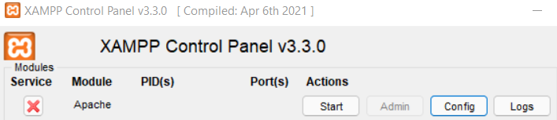
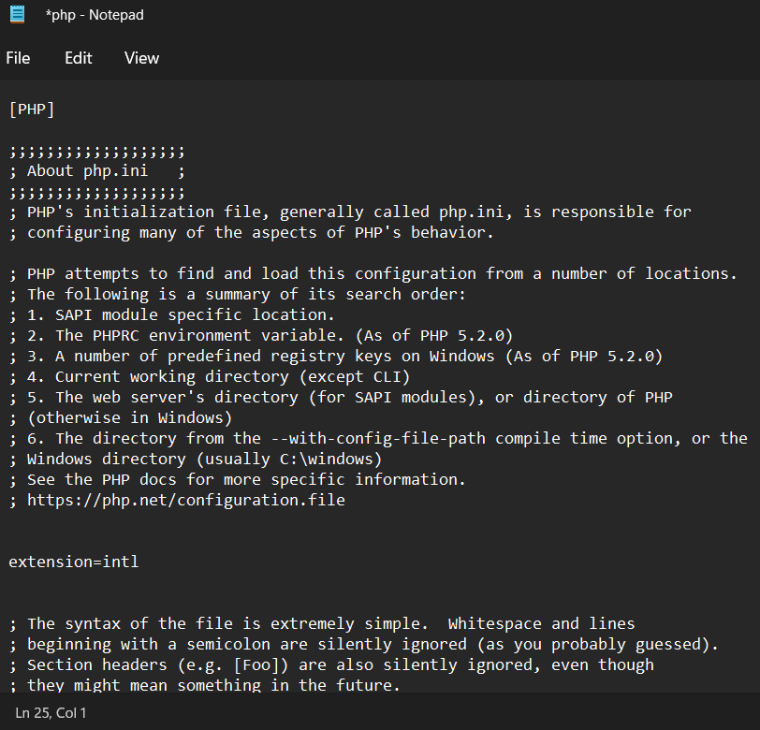

Then run the php spark serve command again. Your antivirus may give a warning about a “rewrite.php” that is part of the framework, it is harmless but if you want to look at it, it is located in Ci4 > System > Commands > Server > rewrite.php

In a browser, go to:
localhost:8080/home for the site to display

I also provided my database for phpMyAdmin so you don’t have to configure database settings, but if you want to the file is located in Ci4 > app > Config > Database.php

